Exercise 1: Print the numbers 1 - 10, each number being a different color.

<!DOCTYPE html>
<html>
<head>
<title>Jvr exercise 1: Print number 1 to 10 with different colors</title></head>

<body>

<div style="width:300px;height:100px;border:2px solid #000;">
<p style="text-align:center;">
Print the numbers 1 - 10 with different color using <b><em>span </em></b> <i>tag </i> <b>aligned center</b> <br> <br>

<span style="background-color:pink;color:red">1</span>
<span style="color:saddlebrown">2</span>
<span style="color:orange">3</span>
<span style="color:maroon">4</span>
<span style="color:gray">5</span>
<span style="color:blue">6</span>
<span style="color:darkslategray">7</span>
<span style="color:indigo">8</span>
<span style="color:darkkhaki">9</span>
<span style="color:tomato">10</span>
</p>
</div>

<br>

<div style="width:300px;height:100px;border:1px solid #000;">
<p>
Print the numbers 1 - 10 with different color using <b><em>font </em></b> <i>tag </i> <br> <br>

<font style="background-color:red;color:black;font-size:150%;" face="halvetic">1</font>
<font style="text-align:center;">2</font>

<font style="color:orange">3</font>
<font style="color:gray">4</font>
<font style="color:maroon">5</font>
<font style="color:blue">6</font>
<font style="color:darkslategray">7</font>
<font style="color:indigo">8</font>
<font style="color:darkkhaki">9</font>
<font style="color:tomato">10</font>
</p>

</div>

<p style="color:indiared;"> <strong>1</strong></p>
<p style="color:crimson;"><strong>2</strong></p>
<p style="color:darkred;"> <font style="background-color:mediumorchid"><b>3</b></font></p>
<p style="color:magenta;"><b>4</b></p>
<p style="color:mediumorchid;"><b>5</b></p>
<p style="color:#663399;"><b>6</b></p>
<p style="color:RGB(0,100,0);"><b>7</b></p>
<p style="color:hsl(0,100%,50%);"><b>8</b></p>
<p style="color:RGBa(0,100,0,90);"><b>9</b></p>
<p style="color:red;"><b>10</b></p>

</body>
</html>

Output:
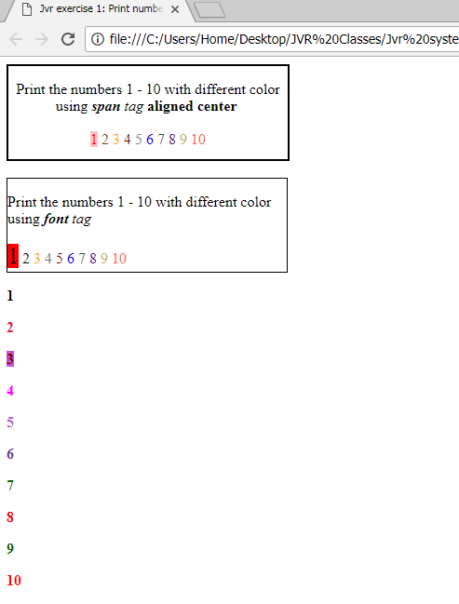

Exercise 2: Prints 10 names with a line break between each name. The list should be alphabetized, and to do this place a subscripted number next to each name based on where it will go in the alphabetized list. (Example: Alan1). Print first, the unalphabetized list with a subscript number next to each name, then the alphabetized list. Both lists should have an <h1> level heading

<!DOCTYPE html>
<html>
<head>
<title>alphabetized list & unalphabetized list of 10 names</title>
</head>
<body>
<h1> Unlphabetized list </h1>
Suchitra <sub>9</sub> <br>
Aravindh <sub>2</sub><br>
Madhu <sub>4</sub><br>
Sridhar <sub>6</sub><br>
Anand <sub>1</sub><br>
Srivanth <sub>8</sub><br>
lallitha <sub>3</sub><br>
Srinivas <sub>3</sub><br>
Vamsi <sub>10</sub><br>
Mahesh <sub>5</sub><br>

<h1> Alphabetized list </h1>
Anand <br>
Aravindh <br>
lallitha <br>
Madhu <br>
Mahesh <br>
Sridhar <br>
Srinivas <br>
Srivanth <br>
Suchitra <br>
Vamsi <br>

</body>
</html>

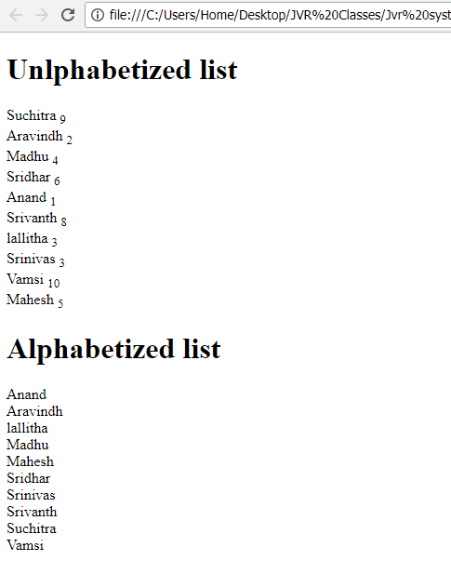

Exercise 3: Create a page with a link at the top of it that when clicked will jump all the way to the bottom of the page. At the bottom of the page there should be a link to jump back to the top of the page.

<!DOCTYPE html>
<html>
<body>

<a href="#bottom" name="top">Navigate to bottom of the page </a>

<h1> Unlphabetized list </h1>
Suchitra <sub>9</sub> <br>
Aravindh <sub>2</sub><br>
Madhu <sub>4</sub><br>
Sridhar <sub>6</sub><br>
Anand <sub>1</sub><br>
Srivanth <sub>8</sub><br>
lallitha <sub>3</sub><br>
Srinivas <sub>3</sub><br>
Vamsi <sub>10</sub><br>
Mahesh <sub>5</sub><br>

<h1> Alphabetized list </h1>
Anand <br>
Aravindh <br>
lallitha <br>
Madhu <br>
Mahesh <br>
Sridhar <br>
Srinivas <br>
Srivanth <br>
Suchitra <br>
Vamsi <br>

<h1> Alphabetized list </h1>
Anand <br>
Aravindh <br>
lallitha <br>
Madhu <br>
Mahesh <br>
Sridhar <br>
Srinivas <br>
Srivanth <br>
Suchitra <br>
Vamsi <br>

<p>Bottom of the page. <a name="bottom" href="#top"> Navigate to top of the page </a> </p>
</body>
</html>

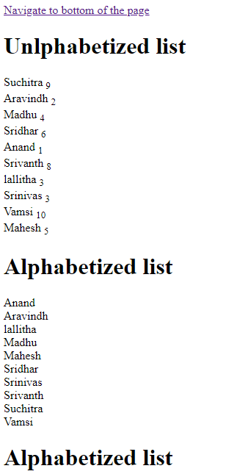

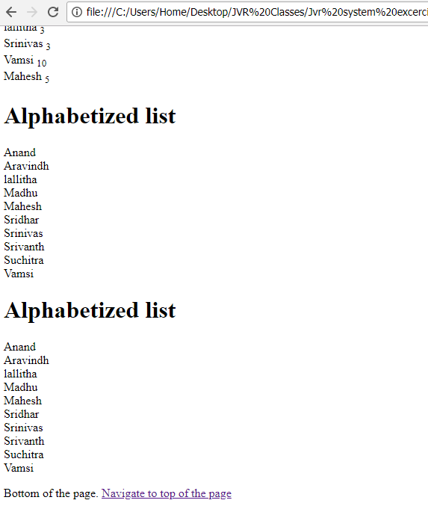

Exercise 4: Display an image that when clicked will link to a search engine of your choice (should be opened in a new window).

<!DOCTYPE html>
<html>

<body>

<p style="text-align:center;">
<a href="http://www.google.com" target="_blank">
<img src="src/relevancy.png" alt="Google search" align="bottom"/> </a></p>

</body>
</html>

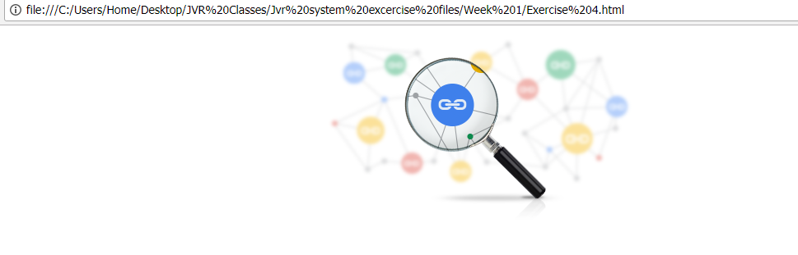

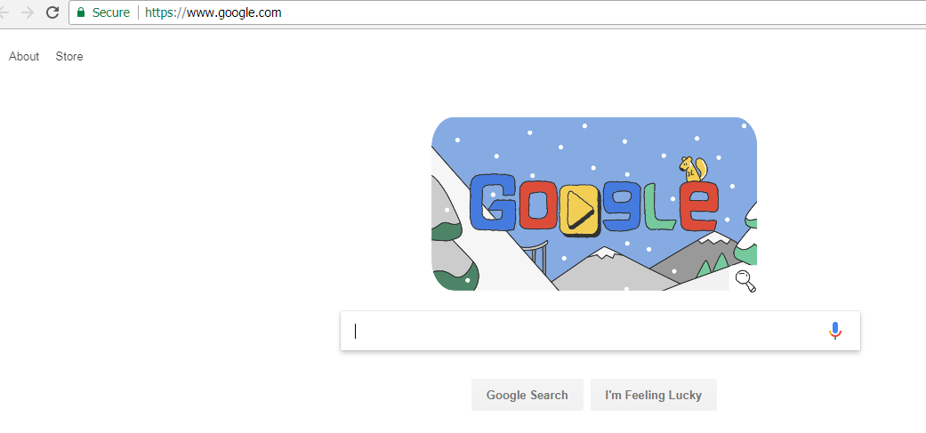

Exercise 5: Make a simple page and put two text inputs and a Submit button into it. Ask for the user's name and address.

<!DOCTYPE html>
<html>
<body>
User Name : <input type="text" name="user name" value=""/>
Address : <input type="text" name="Address" value=""/>
<button>Sumbit</button>
</body>
</html>

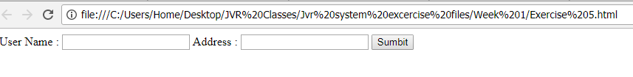

Exercise 6: Ask for a few more things… first name, last name, address, city, state, zip. Arrange things neatly in a borderless table so everything lines up and looks nice and neat

<!DOCTYPE html>
<html>
<body>
<table>
<tr> <td>First Name</td> <td><input type="text" name="First name" value=""</td></tr>
<tr><td>Last Name</td> <td><input type="text" name="Last name" value=""</td></tr>
<tr><td>Address</td> <td><input type="text" name="Address" value=""</td></tr>
<tr><td>City</td> <td><input type="text" name="City" value=""</td></tr>
<tr><td>Zip code</td> <td><input type="text" name="Zipcode" value=""</td></tr>
</table>
<br>
<button type="submit">Sumbit</button>
</body>
</html>

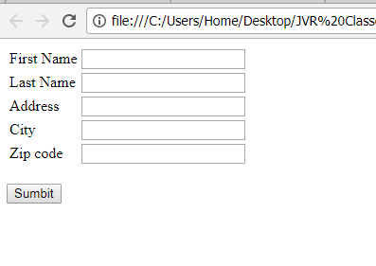

Exercise 7:
create a table to structure the page so that it has:
3 columns: 50 | 500 | 100 pixels wide
4 rows: 50 | 50 | 500 | 50 pixels high

<!DOCTYPE html>
<html>
<body>
<table border="1" style="width:100%">
<tr height=50> <td width=50></td> <td width=500></td> <td width=100></td></tr>
<tr height=50> <td width=50></td> <td width=500></td> <td width=100></td></tr>
<tr height=500> <td width=50></td> <td width=500></td> <td width=100></td></tr>
<tr height=50> <td width=50></td> <td width=500></td> <td width=100></td></tr>
</table>
</body>
</html>

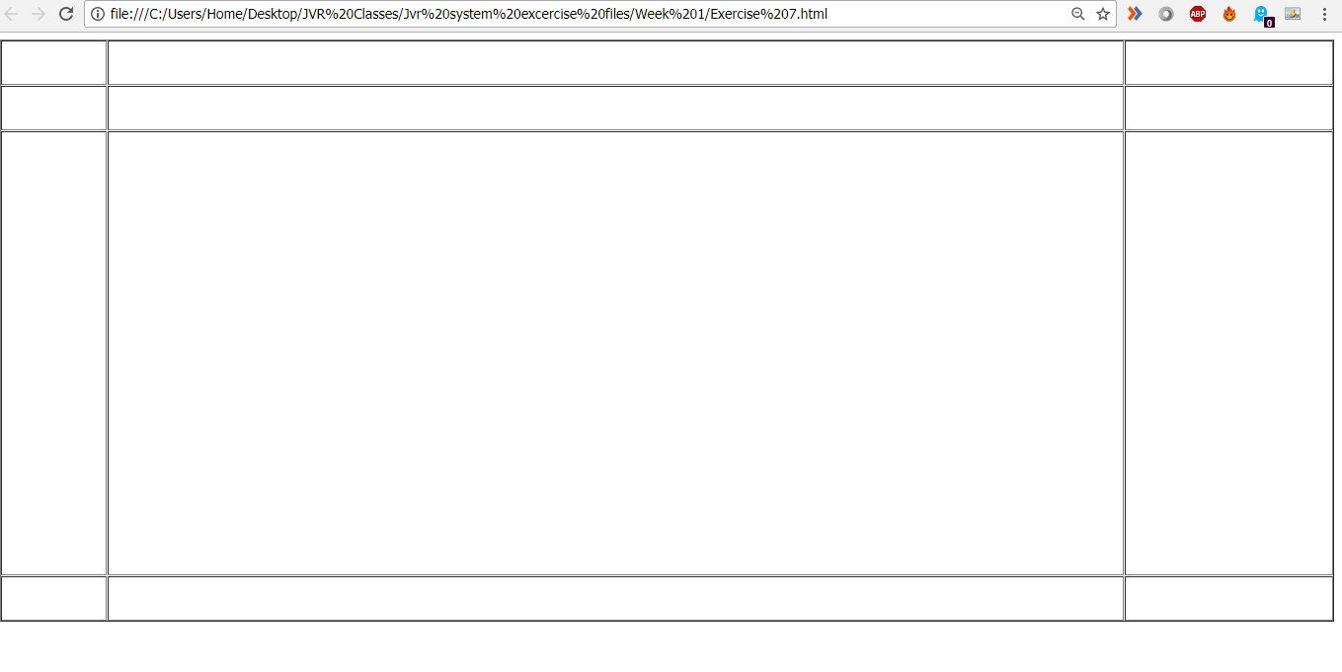

Exercise 8: Embed at least one floating image per page that has text flow all around it.

<!DOCTYPE>
<html>

<body>

<p>
<IMG SRC="img_girl.jpg" ALT="girl in a jacket" style="float:right;width:250px;height:250px">
A junior cadet who died helping other students escape a Florida school shooting has been posthumously accepted into a prestigious US military school.
Peter Wang, 15, one of 17 killed in the 14 February attack, was admitted to the class of 2025 at his dream school, West Point Academy.
He was a member of the US Army Junior Reserve Officers' Training Corps (JROTC), a school programme for potential US military officers.
His funeral took place on Tuesday.
Clooneys make pledge to gun reform march
Florida shooting: Who are the victims?
The school will confer a letter of admission and honorarium tokens to his family, local West Point alumni Chad Maxey told the Sun Sentinel newspaper.
Florida Governor Rick Scott also reportedly directed the state's National Guard to honour Peter and two other members of the JROTC at their funerals.
The US Army bestowed the Medal of Heroism on three students who were killed, including Peter, according to US media.
The Cadet Command also approved Junior ROTC Heroism Medals for 14-year-old cadets Alaina Petty and Martin Duque, an army spokesman told US media.
Peter was in uniform when he was fatally shot while holding the door for others fleeing a gunman at Marjory Stoneman Douglas High School, witnesses say.
The recognition comes after an online petition called for him to be laid to rest with military honours, saying he "deserves" to be buried as a hero, because "his selfless and heroic actions have led to the survival of dozens in the area".
Peter, who had spent part of his childhood in his parents' native China, had dreamed of attending the West Point military academy, friends say.
In Florida aftermath, US students say 'Never Again'
Should US gun raffles be cancelled?
Jesse Pan, a neighbour and longstanding friend of Peter's family, told the BBC Chinese Service he had tried to support the teenager's parents as they struggled to cope with the loss.
"I was there with his parents, helping translating and finding a funeral home," he said.
"His parents fainted as soon as they saw his body. He had got multiple shots in front… So horrible."
Meanwhile, about 100 students from Stoneman Douglas have travelled by bus to the Florida state capitol, where they plan to hold a rally against gun violence on Wednesday.

Some of them arrived on Tuesday in time to see the Republican-controlled state legislature reject a proposed ban on assault weapons and large capacity magazines.

State lawmakers voted down the measure after opening their session with a prayer for the victims of the Parkland high school shooting.

The students, whose school is shut until 27 February, are hoping their march inspires others across the US.

A larger protest is being planned for Washington DC on 24 March.</p>

</body>
</html>

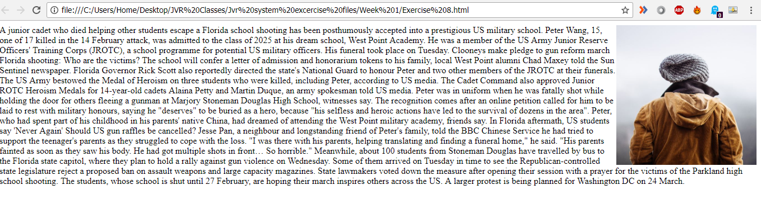

Exercise 9: Create Google Analytics account and create and embed tracking code on your build pages you created above. Use 6 and 7 for this exercise

Pending…

Exercise 10: CSS Should have the below:
Use a paragraph <p>…</p> to hold the text.
Use <span** style="…">text</span>** for the colored text

<!DOCTYPE html>
<html>
<head>
<style>
body

p {
font-family: calibri;
font-size: 15px;
line-height:1.2em;
text-align: justify;
background-color: LEMONCHIFFON;
color: PURPLE;
}

span {
font-family: sans-serif;
font-size: 15px;
color: black;
line-height:1.2em

}

span.style1 {
font-family: georgia;
font-size: 15px;
color: blue;
line-height:1.2em

}

</style>
</head>
<body>

<p>
Please use the sharing tools found via the email icon at the top of articles. Copying articles to share with others is a breach of FT.com T&Cs and Copyright Policy. Email licensing@ft.com to buy additional rights. Subscribers may share up to 10 or 20 articles per month using the gift article service.

<span>The $21m fine levied on Google by India’s competition watchdog for abuse of market dominance </span> was just one-hundredth the size of that imposed last year by its counterpart in Brussels.

Yet this month’s penalty appears to be just a prelude to New Delhi securing a greater share of the revenue of US digital giants, some of which have hundreds of millions of users in India but report only a tiny portion of their profit there.

The push could also see India taking a leading role as global governments struggle to decide on a system for <span class="style1">taxing multinational companies in the digital age </span>.
</p>

</body>
</html>

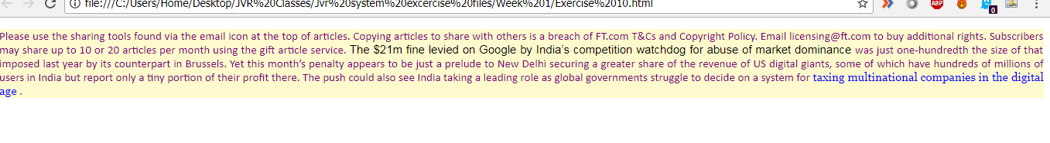

Exercise 11:
CSS should have the below
Use 3 nested <div> elements
Outside div : blue dotted border + border-radius + padding
Middle div : red dashed border + border-radius + padding
Inner div : green solid border + border-radius + padding + text-align + font-size
Use &lt; and &gt; to escape the < and > characters in the text…

<!DOCTYPE html>
<html>
<head>
<style>
div.outside {

width: 530px;
border: 8px blue;
padding: 10px;
margin: 25px;
border-style: dotted;
border-radius: 10px;
}

div.middle {
width: 400px;
border: 8px red;
padding: 10px;
margin: 40px;
border-style: dashed;
border-radius: 10px;
}

div.inner {
width: 280px;
border: 8px solid green;
padding: 15px;
margin: 40px;
/*-- border-style: dashed; --*/
border-radius: 10px;
text-align: justify;
font-size: 25;
}
</style>
</head>
<body>

<div class="outside">

<div class="middle">

<div class="inner">
The automated accounts follow a pattern: “The bots focus on anything that is divisive for Americans. Almost systematically,” said an executive at a company that tracks online <disinformation> campaigns.</div>

</div>
</div>
</body>
</html>

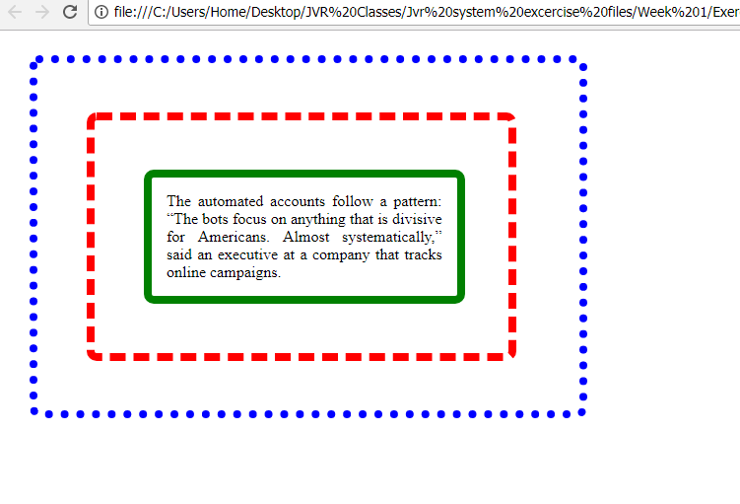
Exercise 12:
CSS should have the below
Use three paragraphs <p>…</p> to hold the text
Use <p style="">…</p> to style the paragraphs
Use <span** style="…">text</span>** for the colored text

<!DOCTYPE html>
<html>
<head>
<style>

p.style1 {
font-family: arial;
font-size: 15px;
line-height:1.5em;
text-align: justify;
color: red;
}

p.style2 {
font-family: sans-serif;
font-size: 15px;
line-height:1.5em;
text-align: justify;
color: maroon;
}

p.style3 {
font-family: helvetica;
font-size: 15px;
line-height:1.2em;
text-align: justify;
color: orange
}

span.style1 {
font-family: georgia;
font-size: 15px;
color: blue;
line-height:1.2em

}

</style>
</head>

<body>

<p class="style1">
Please use the sharing tools found via the email icon at the top of articles. Copying articles to share with others is a breach of FT.com T&Cs and Copyright Policy. Email licensing@ft.com to buy additional rights. Subscribers may share up to 10 or 20 articles per month using the gift article service. More information can be found at https://www.ft.com/tour.
https://www.ft.com/content/9609a0ca-0d99-11e8-8eb7-42f857ea9f09 </p>

<p class="style2"> The $21m fine levied on Google by India’s competition watchdog for abuse of market dominance was just one-hundredth the size of that imposed last year by its counterpart in Brussels. </p>

<p class="style3">Yet this month’s penalty appears to be just a prelude to New Delhi securing a greater share of the revenue of US digital giants, some of which have hundreds of millions of users in India <span class="style1">but report only a tiny portion of their profit there </span>.

The push could also see India taking a leading role as global governments struggle to decide on a system for taxing multinational companies in the digital age.
</p>

</body>
</html>

